***What are APIs Application Programming Interfaces Demystified?***

**APIs:** Application Programming Interfaces

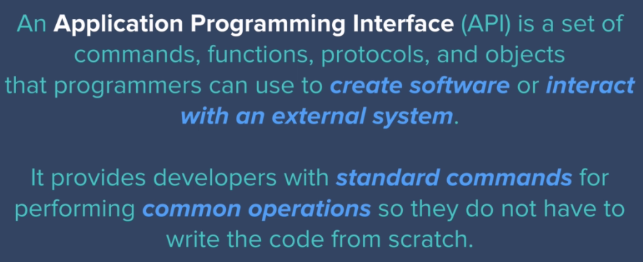

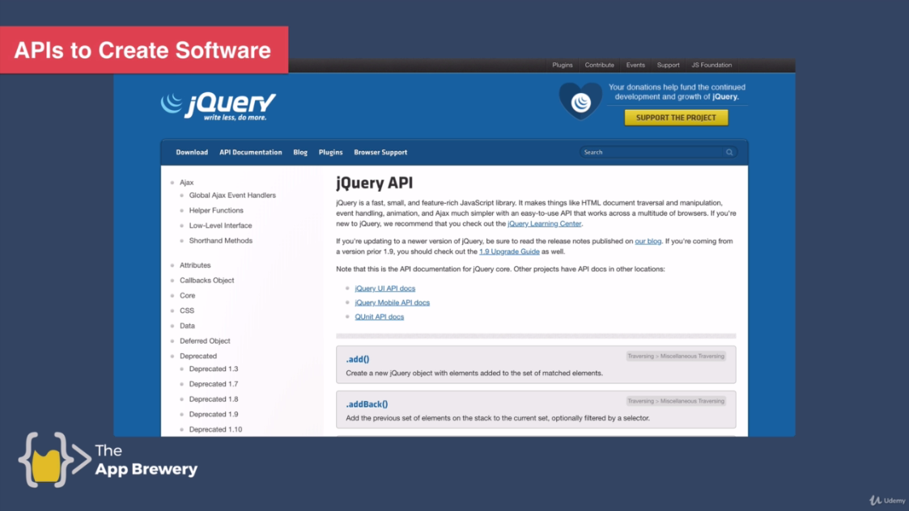

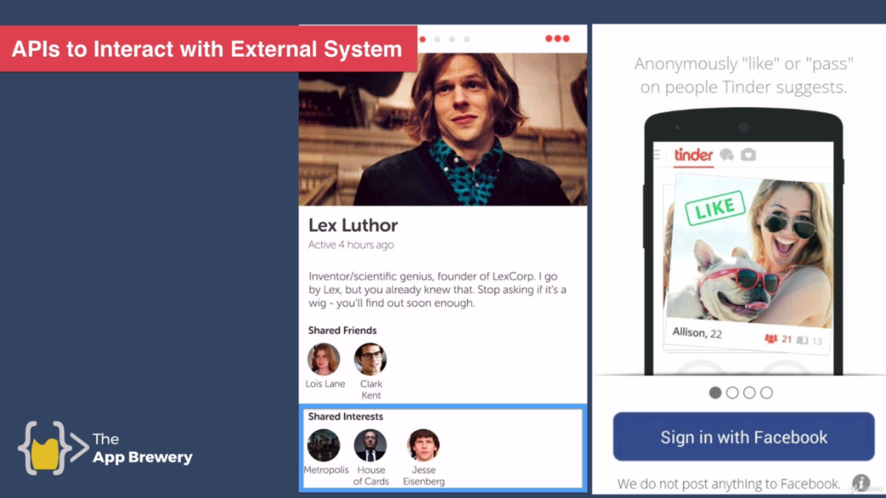

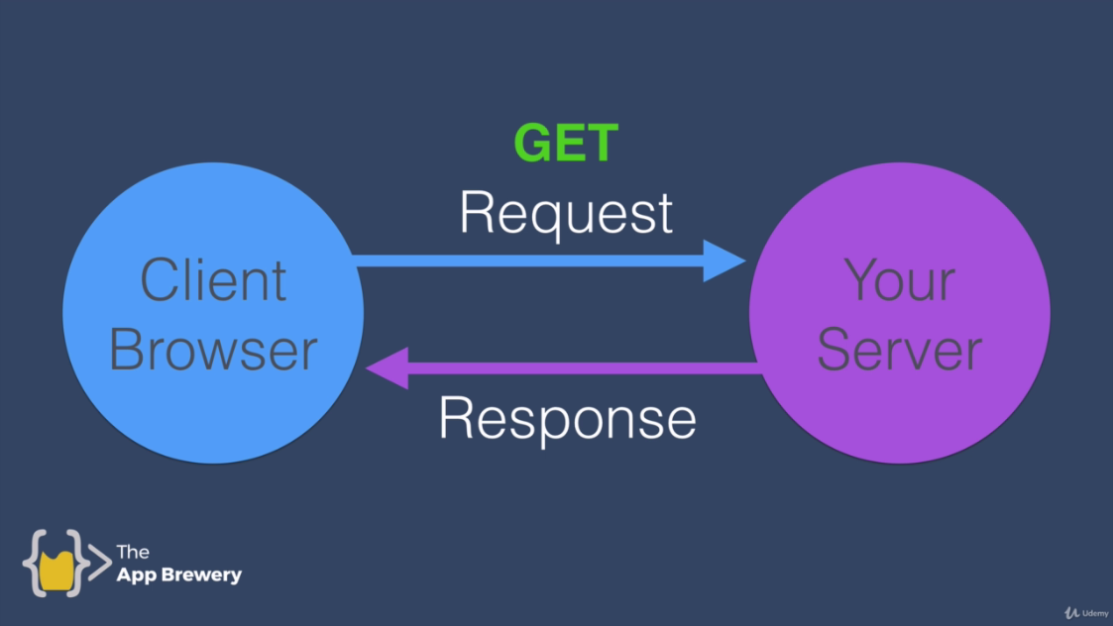

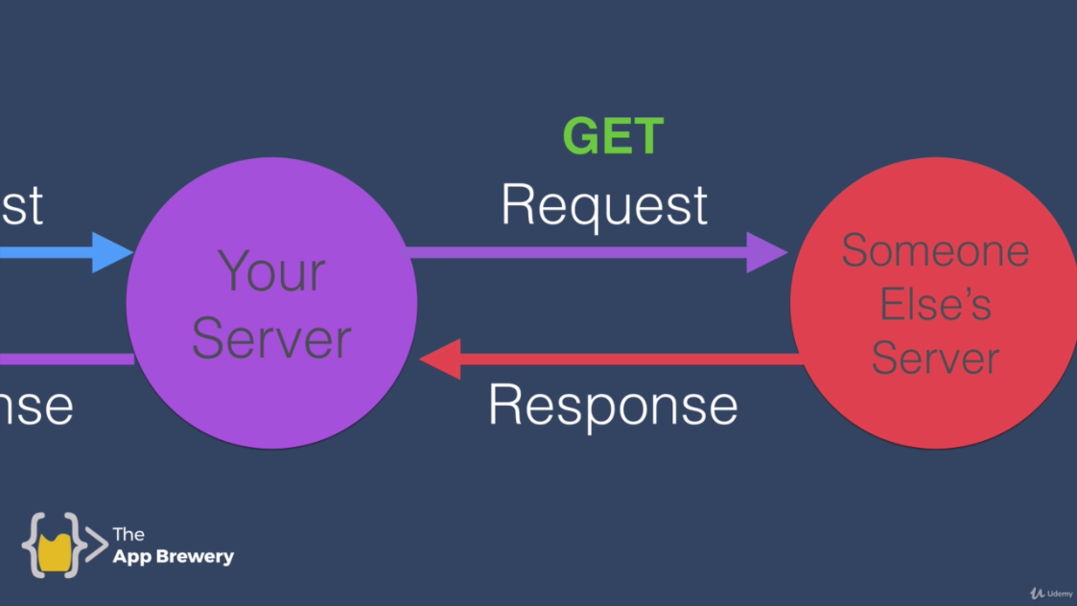

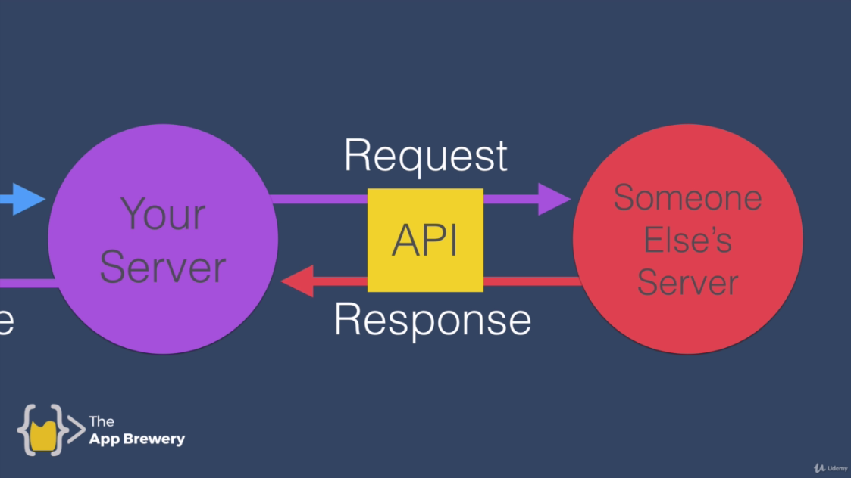

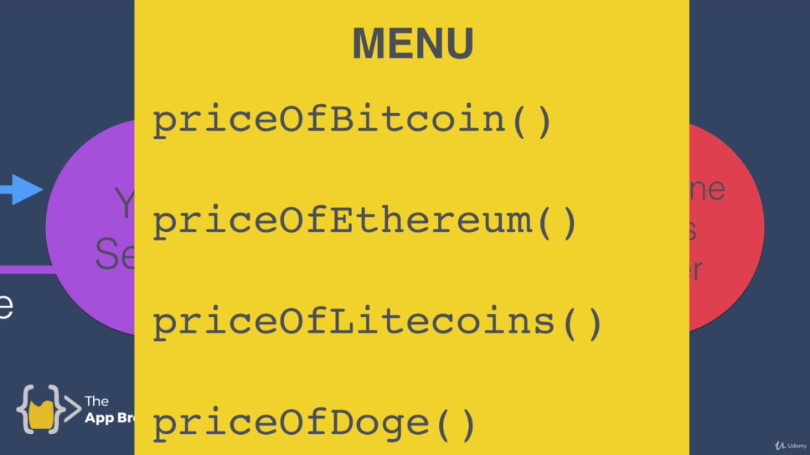

<https://bitcoinaverage.com>

documentation describes how you can interact with particular API.

<https://apiv2.bitcoinaverage.com>

<https://curl.se>

cURL: client for urls

**curl –-help** command

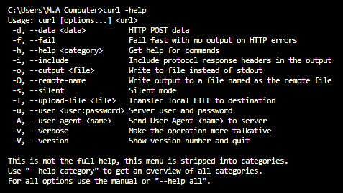

**curl --help all**

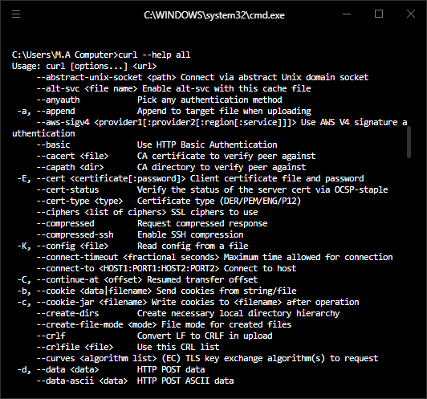

**C:\Users\M.A Computer>curl --help all**

**Usage: curl [options...] <url>**

**--abstract-unix-socket <path> Connect via abstract Unix domain socket**

**--alt-svc <file name> Enable alt-svc with this cache file**

**--anyauth Pick any authentication method**

**-a, --append Append to target file when uploading**

**--aws-sigv4 <provider1[:provider2[:region[:service]]]> Use AWS V4 signature authentication**

**--basic Use HTTP Basic Authentication**

**--cacert <file> CA certificate to verify peer against**

**--capath <dir> CA directory to verify peer against**

**-E, --cert <certificate[:password]> Client certificate file and password**

**--cert-status Verify the status of the server cert via OCSP-staple**

**--cert-type <type> Certificate type (DER/PEM/ENG/P12)**

**--ciphers <list of ciphers> SSL ciphers to use**

**--compressed Request compressed response**

**--compressed-ssh Enable SSH compression**

**-K, --config <file> Read config from a file**

**--connect-timeout <fractional seconds> Maximum time allowed for connection**

**--connect-to <HOST1:PORT1:HOST2:PORT2> Connect to host**

**-C, --continue-at <offset> Resumed transfer offset**

**-b, --cookie <data|filename> Send cookies from string/file**

**-c, --cookie-jar <filename> Write cookies to <filename> after operation**

**--create-dirs Create necessary local directory hierarchy**

**--create-file-mode <mode> File mode for created files**

**--crlf Convert LF to CRLF in upload**

**--crlfile <file> Use this CRL list**

**--curves <algorithm list> (EC) TLS key exchange algorithm(s) to request**

**-d, --data <data> HTTP POST data**

**--data-ascii <data> HTTP POST ASCII data**

**--data-binary <data> HTTP POST binary data**

**--data-raw <data> HTTP POST data, '@' allowed**

**--data-urlencode <data> HTTP POST data URL encoded**

**--delegation <LEVEL> GSS-API delegation permission**

**--digest Use HTTP Digest Authentication**

**-q, --disable Disable .curlrc**

**--disable-eprt Inhibit using EPRT or LPRT**

**--disable-epsv Inhibit using EPSV**

**--disallow-username-in-url Disallow username in URL**

**--dns-interface <interface> Interface to use for DNS requests**

**--dns-ipv4-addr <address> IPv4 address to use for DNS requests**

**--dns-ipv6-addr <address> IPv6 address to use for DNS requests**

**--dns-servers <addresses> DNS server addrs to use**

**--doh-cert-status Verify the status of the DoH server cert via OCSP-stape**

**--doh-insecure Allow insecure DoH server connections**

**--doh-url <URL> Resolve host names over DoH**

**-D, --dump-header <filename> Write the received headers to <filename>**

**--egd-file <file> EGD socket path for random data**

**--engine <name> Crypto engine to use**

**--etag-compare <file> Pass an ETag from a file as a custom header**

**--etag-save <file> Parse ETag from a request and save it to a file**

**--expect100-timeout <seconds> How long to wait for 100-continue**

**-f, --fail Fail fast with no output on HTTP errors**

**--fail-early Fail on first transfer error, do not continue**

**--fail-with-body Fail on HTTP errors but save the body**

**--false-start Enable TLS False Start**

**-F, --form <name=content> Specify multipart MIME data**

**--form-escape Escape multipart form field/file names using backslash**

**--form-string <name=string> Specify multipart MIME data**

**--ftp-account <data> Account data string**

**--ftp-alternative-to-user <command> String to replace USER [name]**

**--ftp-create-dirs Create the remote dirs if not present**

**--ftp-method <method> Control CWD usage**

**--ftp-pasv Use PASV/EPSV instead of PORT**

**-P, --ftp-port <address> Use PORT instead of PASV**

**--ftp-pret Send PRET before PASV**

**--ftp-skip-pasv-ip Skip the IP address for PASV**

**--ftp-ssl-ccc Send CCC after authenticating**

**--ftp-ssl-ccc-mode <active/passive> Set CCC mode**

**--ftp-ssl-control Require SSL/TLS for FTP login, clear for transfer**

**-G, --get Put the post data in the URL and use GET**

**-g, --globoff Disable URL sequences and ranges using {} and []**

**--happy-eyeballs-timeout-ms <milliseconds> Time for IPv6 before trying IPv4**

**--haproxy-protocol Send HAProxy PROXY protocol v1 header**

**-I, --head Show document info only**

**-H, --header <header/@file> Pass custom header(s) to server**

**-h, --help <category> Get help for commands**

**--hostpubmd5 <md5> Acceptable MD5 hash of the host public key**

**--hostpubsha256 <sha256> Acceptable SHA256 hash of the host public key**

**--hsts <file name> Enable HSTS with this cache file**

**--http0.9 Allow HTTP 0.9 responses**

**-0, --http1.0 Use HTTP 1.0**

**--http1.1 Use HTTP 1.1**

**--http2 Use HTTP 2**

**--http2-prior-knowledge Use HTTP 2 without HTTP/1.1 Upgrade**

**--http3 Use HTTP v3**

**--ignore-content-length Ignore the size of the remote resource**

**-i, --include Include protocol response headers in the output**

**-k, --insecure Allow insecure server connections**

**--interface <name> Use network INTERFACE (or address)**

**-4, --ipv4 Resolve names to IPv4 addresses**

**-6, --ipv6 Resolve names to IPv6 addresses**

**--json <data> HTTP POST JSON**

**-j, --junk-session-cookies Ignore session cookies read from file**

**--keepalive-time <seconds> Interval time for keepalive probes**

**--key <key> Private key file name**

**--key-type <type> Private key file type (DER/PEM/ENG)**

**--krb <level> Enable Kerberos with security <level>**

**--libcurl <file> Dump libcurl equivalent code of this command line**

**--limit-rate <speed> Limit transfer speed to RATE**

**-l, --list-only List only mode**

**--local-port <num/range> Force use of RANGE for local port numbers**

**-L, --location Follow redirects**

**--location-trusted Like --location, and send auth to other hosts**

**--login-options <options> Server login options**

**--mail-auth <address> Originator address of the original email**

**--mail-from <address> Mail from this address**

**--mail-rcpt <address> Mail to this address**

**--mail-rcpt-allowfails Allow RCPT TO command to fail for some recipients**

**-M, --manual Display the full manual**

**--max-filesize <bytes> Maximum file size to download**

**--max-redirs <num> Maximum number of redirects allowed**

**-m, --max-time <fractional seconds> Maximum time allowed for transfer**

**--metalink Process given URLs as metalink XML file**

**--negotiate Use HTTP Negotiate (SPNEGO) authentication**

**-n, --netrc Must read .netrc for user name and password**

**--netrc-file <filename> Specify FILE for netrc**

**--netrc-optional Use either .netrc or URL**

**-:, --next Make next URL use its separate set of options**

**--no-alpn Disable the ALPN TLS extension**

**-N, --no-buffer Disable buffering of the output stream**

**--no-clobber Do not overwrite files that already exist**

**--no-keepalive Disable TCP keepalive on the connection**

**--no-npn Disable the NPN TLS extension**

**--no-progress-meter Do not show the progress meter**

**--no-sessionid Disable SSL session-ID reusing**

**--noproxy <no-proxy-list> List of hosts which do not use proxy**

**--ntlm Use HTTP NTLM authentication**

**--ntlm-wb Use HTTP NTLM authentication with winbind**

**--oauth2-bearer <token> OAuth 2 Bearer Token**

**-o, --output <file> Write to file instead of stdout**

**--output-dir <dir> Directory to save files in**

**-Z, --parallel Perform transfers in parallel**

**--parallel-immediate Do not wait for multiplexing (with --parallel)**

**--parallel-max <num> Maximum concurrency for parallel transfers**

**--pass <phrase> Pass phrase for the private key**

**--path-as-is Do not squash .. sequences in URL path**

**--pinnedpubkey <hashes> FILE/HASHES Public key to verify peer against**

**--post301 Do not switch to GET after following a 301**

**--post302 Do not switch to GET after following a 302**

**--post303 Do not switch to GET after following a 303**

**--preproxy [protocol://]host[:port] Use this proxy first**

**-#, --progress-bar Display transfer progress as a bar**

**--proto <protocols> Enable/disable PROTOCOLS**

**--proto-default <protocol> Use PROTOCOL for any URL missing a scheme**

**--proto-redir <protocols> Enable/disable PROTOCOLS on redirect**

**-x, --proxy [protocol://]host[:port] Use this proxy**

**--proxy-anyauth Pick any proxy authentication method**

**--proxy-basic Use Basic authentication on the proxy**

**--proxy-cacert <file> CA certificate to verify peer against for proxy**

**--proxy-capath <dir> CA directory to verify peer against for proxy**

**--proxy-cert <cert[:passwd]> Set client certificate for proxy**

**--proxy-cert-type <type> Client certificate type for HTTPS proxy**

**--proxy-ciphers <list> SSL ciphers to use for proxy**

**--proxy-crlfile <file> Set a CRL list for proxy**

**--proxy-digest Use Digest authentication on the proxy**

**--proxy-header <header/@file> Pass custom header(s) to proxy**

**--proxy-insecure Do HTTPS proxy connections without verifying the proxy**

**--proxy-key <key> Private key for HTTPS proxy**

**--proxy-key-type <type> Private key file type for proxy**

**--proxy-negotiate Use HTTP Negotiate (SPNEGO) authentication on the proxy**

**--proxy-ntlm Use NTLM authentication on the proxy**

**--proxy-pass <phrase> Pass phrase for the private key for HTTPS proxy**

**--proxy-pinnedpubkey <hashes> FILE/HASHES public key to verify proxy with**

**--proxy-service-name <name> SPNEGO proxy service name**

**--proxy-ssl-allow-beast Allow security flaw for interop for HTTPS proxy**

**--proxy-ssl-auto-client-cert Use auto client certificate for proxy (Schannel) --proxy-tls13-ciphers <ciphersuite list> TLS 1.3 proxy cipher suites**

**--proxy-tlsauthtype <type> TLS authentication type for HTTPS proxy**

**--proxy-tlspassword <string> TLS password for HTTPS proxy**

**--proxy-tlsuser <name> TLS username for HTTPS proxy**

**--proxy-tlsv1 Use TLSv1 for HTTPS proxy**

**-U, --proxy-user <user:password> Proxy user and password**

**--proxy1.0 <host[:port]> Use HTTP/1.0 proxy on given port**

**-p, --proxytunnel Operate through an HTTP proxy tunnel (using CONNECT)**

**--pubkey <key> SSH Public key file name**

**-Q, --quote <command> Send command(s) to server before transfer**

**--random-file <file> File for reading random data from**

**-r, --range <range> Retrieve only the bytes within RANGE**

**--raw Do HTTP "raw"; no transfer decoding**

**-e, --referer <URL> Referrer URL**

**-J, --remote-header-name Use the header-provided filename**

**-O, --remote-name Write output to a file named as the remote file**

**--remote-name-all Use the remote file name for all URLs**

**-R, --remote-time Set the remote file's time on the local output**

**--remove-on-error Remove output file on errors**

**-X, --request <method> Specify request method to use**

**--request-target <path> Specify the target for this request**

**--resolve <[+]host:port:addr[,addr]...> Resolve the host+port to this address --retry <num> Retry request if transient problems occur**

**--retry-all-errors Retry all errors (use with --retry)**

**--retry-connrefused Retry on connection refused (use with --retry)**

**--retry-delay <seconds> Wait time between retries**

**--retry-max-time <seconds> Retry only within this period**

**--sasl-authzid <identity> Identity for SASL PLAIN authentication**

**--sasl-ir Enable initial response in SASL authentication**

**--service-name <name> SPNEGO service name**

**-S, --show-error Show error even when -s is used**

**-s, --silent Silent mode**

**--socks4 <host[:port]> SOCKS4 proxy on given host + port**

**--socks4a <host[:port]> SOCKS4a proxy on given host + port**

**--socks5 <host[:port]> SOCKS5 proxy on given host + port**

**--socks5-basic Enable username/password auth for SOCKS5 proxies**

**--socks5-gssapi Enable GSS-API auth for SOCKS5 proxies**

**--socks5-gssapi-nec Compatibility with NEC SOCKS5 server**

**--socks5-gssapi-service <name> SOCKS5 proxy service name for GSS-API**

**--socks5-hostname <host[:port]> SOCKS5 proxy, pass host name to proxy**

**-Y, --speed-limit <speed> Stop transfers slower than this**

**-y, --speed-time <seconds> Trigger 'speed-limit' abort after this time**

**--ssl Try SSL/TLS**

**--ssl-allow-beast Allow security flaw to improve interop**

**--ssl-auto-client-cert Use auto client certificate (Schannel)**

**--ssl-no-revoke Disable cert revocation checks (Schannel)**

**--ssl-reqd Require SSL/TLS**

**--ssl-revoke-best-effort Ignore missing/offline cert CRL dist points**

**-2, --sslv2 Use SSLv2**

**-3, --sslv3 Use SSLv3**

**--stderr <file> Where to redirect stderr**

**--styled-output Enable styled output for HTTP headers**

**--suppress-connect-headers Suppress proxy CONNECT response headers**

**--tcp-fastopen Use TCP Fast Open**

**--tcp-nodelay Use the TCP_NODELAY option**

**-t, --telnet-option <opt=val> Set telnet option**

**--tftp-blksize <value> Set TFTP BLKSIZE option**

**--tftp-no-options Do not send any TFTP options**

**-z, --time-cond <time> Transfer based on a time condition**

**--tls-max <VERSION> Set maximum allowed TLS version**

**--tls13-ciphers <ciphersuite list> TLS 1.3 cipher suites to use**

**--tlsauthtype <type> TLS authentication type**

**--tlspassword <string> TLS password**

**--tlsuser <name> TLS user name**

**-1, --tlsv1 Use TLSv1.0 or greater**

**--tlsv1.0 Use TLSv1.0 or greater**

**--tlsv1.1 Use TLSv1.1 or greater**

**--tlsv1.2 Use TLSv1.2 or greater**

**--tlsv1.3 Use TLSv1.3 or greater**

**--tr-encoding Request compressed transfer encoding**

**--trace <file> Write a debug trace to FILE**

**--trace-ascii <file> Like --trace, but without hex output**

**--trace-time Add time stamps to trace/verbose output**

**--unix-socket <path> Connect through this Unix domain socket**

**-T, --upload-file <file> Transfer local FILE to destination**

**--url <url> URL to work with**

**-B, --use-ascii Use ASCII/text transfer**

**-u, --user <user:password> Server user and password**

**-A, --user-agent <name> Send User-Agent <name> to server**

**-v, --verbose Make the operation more talkative**

**-V, --version Show version number and quit**

**-w, --write-out <format> Use output FORMAT after completion**

**--xattr Store metadata in extended file attributes**

Let’s make simple get request to google server:

**curl** [**http://www.google.com**](http://www.google.com)

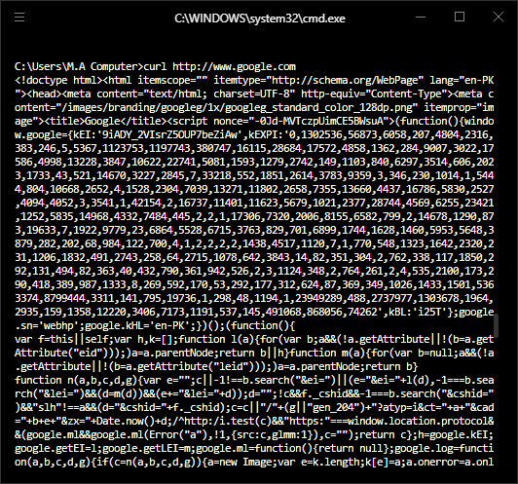

It is basically simple html code copy paste it in atom and check.

See google.html file.

**Bitcoin data:**

curl https://apiv2.bitcoinaverage.com/indices/global/ticker/**BTCUSD**

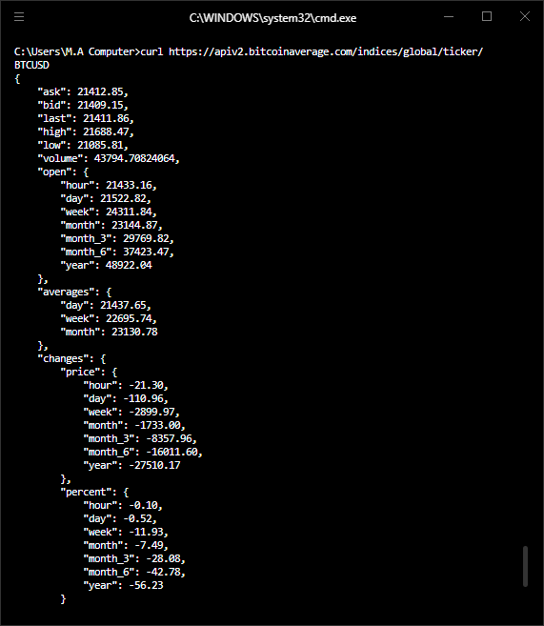

**JSON Format**

**curl https://apiv2.bitcoinaverage.com/indices/global/ticker/ETHEUR**

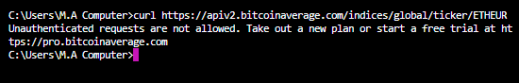

First sign in.



Some of the requests allows you to provide a parameter.

<https://apiv2.bitcoinaverage.com/#historical-data>

<https://apiv2.bitcoinaverage.com/#price-at-timestamp>

Unix timestamp:

<https://www.unixtimestamp.com>

curl -H "X-Testing: testing" https://apiv2.bitcoinaverage.com/indices/global/history/BTCUSD?at=1402476700&resolution=day

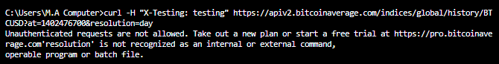



at=no of seconds by unix time stamp.

|  |  |  |
| --- | --- | --- |
| **since** | **True** | **Timestamp in unix format. Example: 1402476700** |

Imagine the server as bank:





<https://apiv2.bitcoinaverage.com/#authentication>

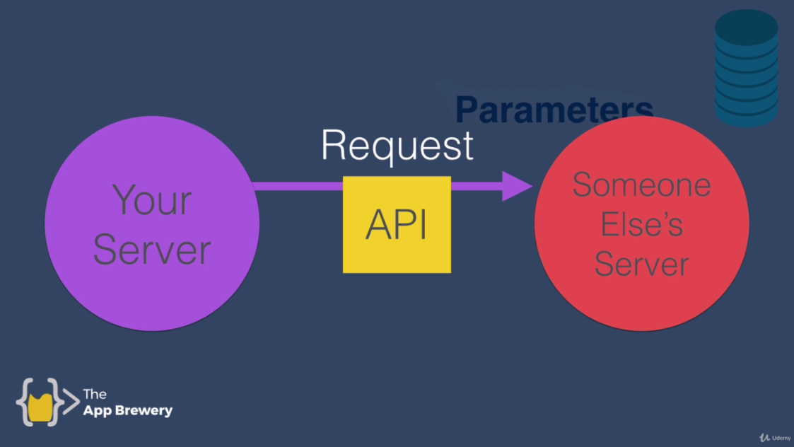

Parameters as input.



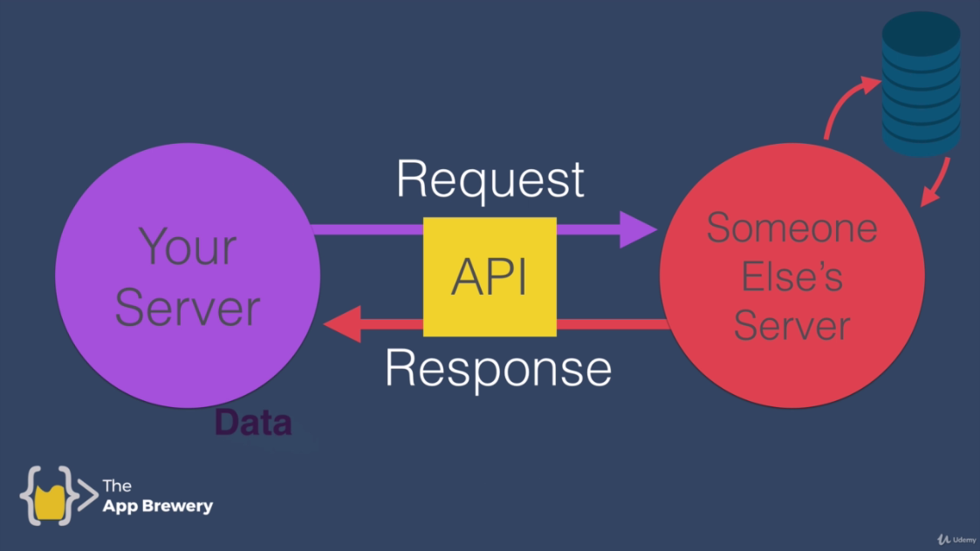

Data from database to your server and from your server to database.

<https://apiv2.bitcoinaverage.com/#introduction>

**Explore different APIs:**

<https://any-api.com>

Private vs Public APIs